**BSc (Hons) in Information Technology**

**Specializing in Data Science**

IT3021 – Data Warehousing and Business Intelligence

Year 3

Assignment 2 Semester 1, 2025

IT Number: IT22555144

Name: Unagalle U.C.P

**Table of Content**

Page No

**Step 1:** Data Source for the Assignment 2 2 - 3

**Step 2:** SSAS Cube Implementation 4 – 13

**Step 3:** Demonstration of OLAP operation 14 – 18

**Step 4:** Power BI Reports 19 - 25

**Step 1: Data source for the assignment 2**

**Description of the data source:**

**Dataset Name**: Contoso 100K Database

**Source:** [Contoso 100K Database](https://red9.com/blog/sample-sql-databases/)  
**Data Period:** The dataset spans over multiple years of sales transactions.

**Data Format:** SQL Database files, CSV files, TXT files

**Description:**

The Contoso 100K Database is a sample dataset that simulates real-world retail business operations. It contains approximately 100,000 records, making it ideal for data warehousing, ETL, SSAS cube modeling, and business intelligence (BI) reporting. This dataset follows an **OLTP structure**, making it suitable for analysis and data warehouse design.

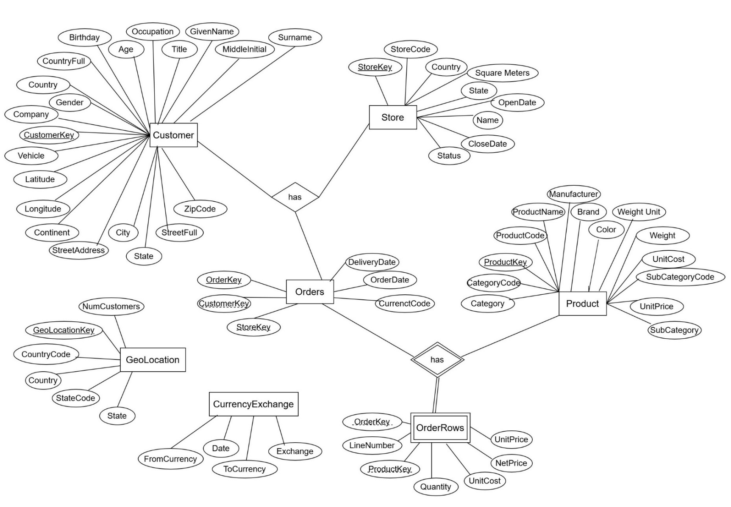**ER Diagram**

**ER Diagram**

**Overall System Diagram**

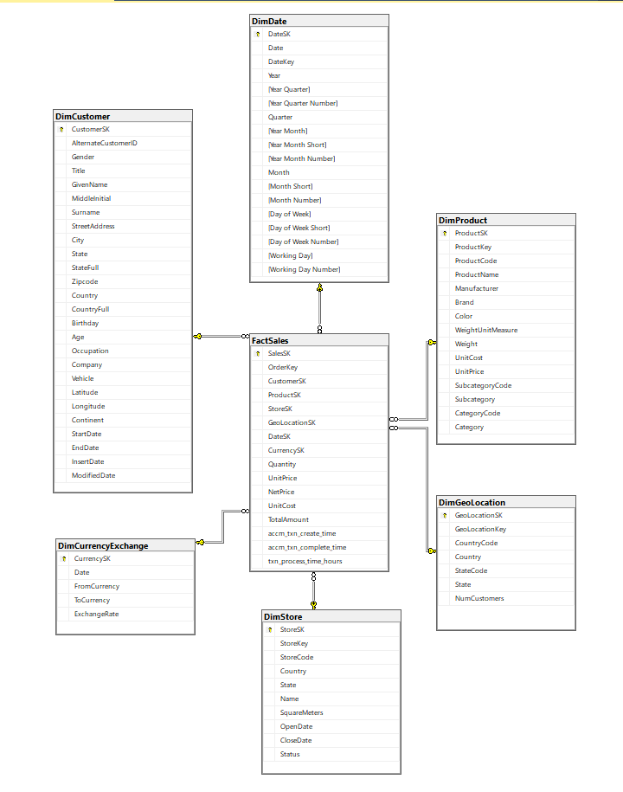

**Step 2: SSAS Cube implementation**

**1. Creating the SSAS Project**

* Opened Visual Studio.
* Created a new project:
  + Project Type: Analysis Services Multidimensional and Data Mining Project
  + Project Name: CubeProject_IT22555144
* Clicked OK to create the SSAS project workspace.

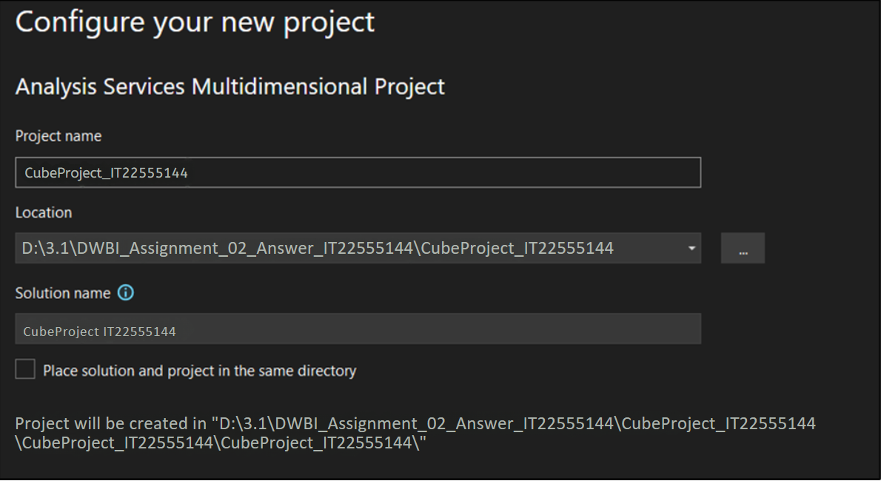

**2. Setting up Data Source**

* Right-clicked on **Data Sources** → **New Data Source**.
* Selected existing **Data Warehouse** database as source.
* Chose the connection:
  + Database: Contoso_DW
* Selected Use the service account.
* Completed the Data Source wizard.

Step 2

Step 1

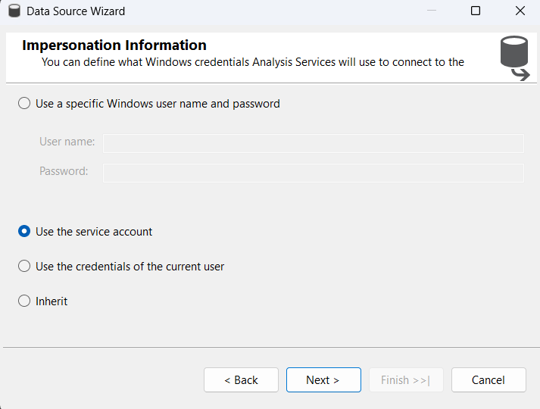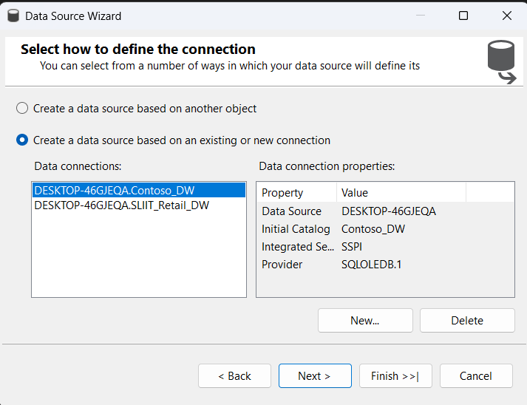

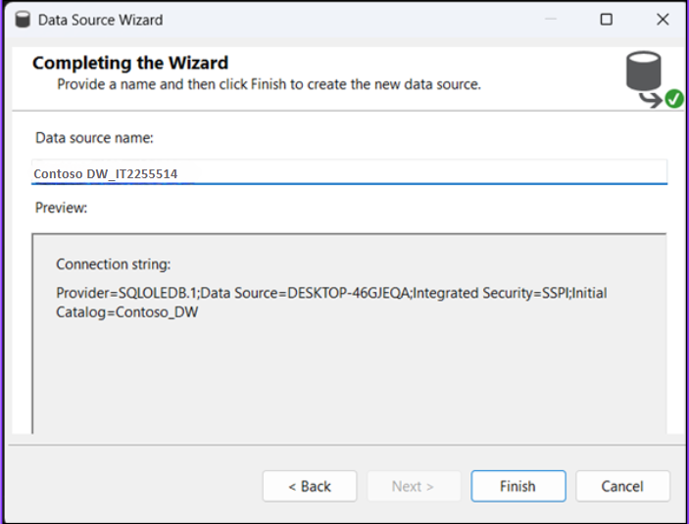

Step 3

**3. Setting up Data Source View (DSV)**

* Right-clicked on **Data Source Views** → **New Data Source View**.
* Added relevant tables:
  + **Fact Table** (FactSales)
  + **Dimension Tables** (DimCustomer, DimGeoLocation, DimDate, DimCurrencyExchange, DimProduct, DimStore)
* Verified relationships were automatically detected (Fact Table foreign keys to Dimension primary keys).

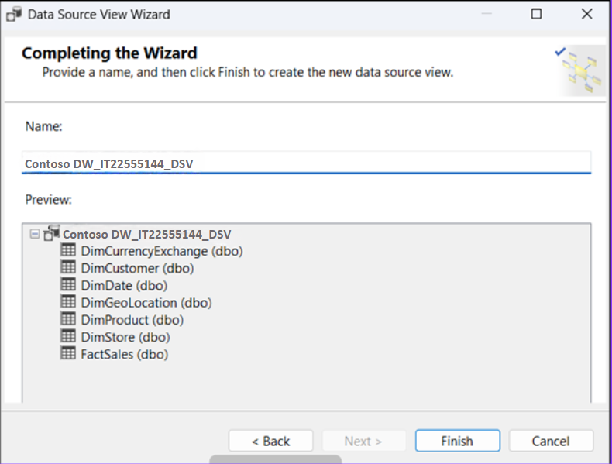

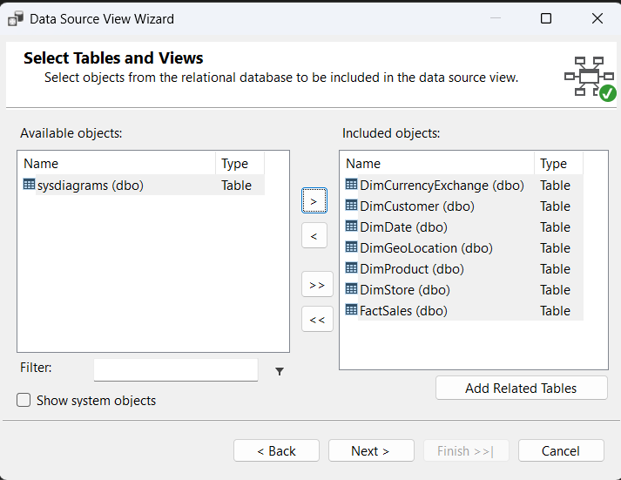

Step 1

Step 2

**4. Creating the Cube**

* Right-clicked on **Cubes** → **New Cube** → **Cube Wizard**.
* Selected **Use Existing Tables**.
* Chose the **Fact Table** (FactSales).
* Selected measures automatically detected by the wizard.
* Added related dimensions (already connected in DSV).
* Completed the Cube Wizard.

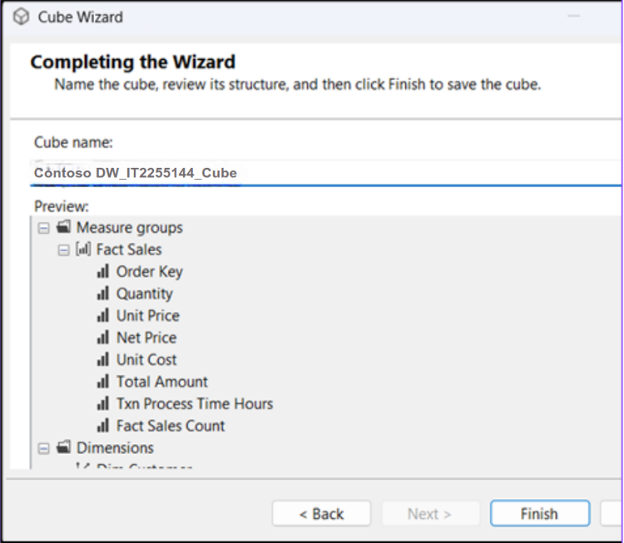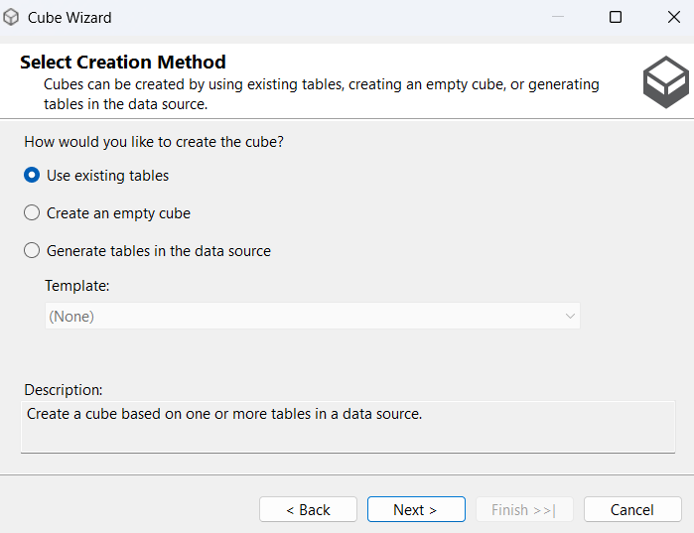

Step 2

Step 1

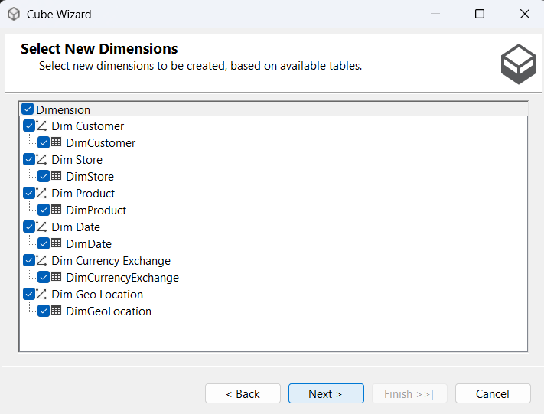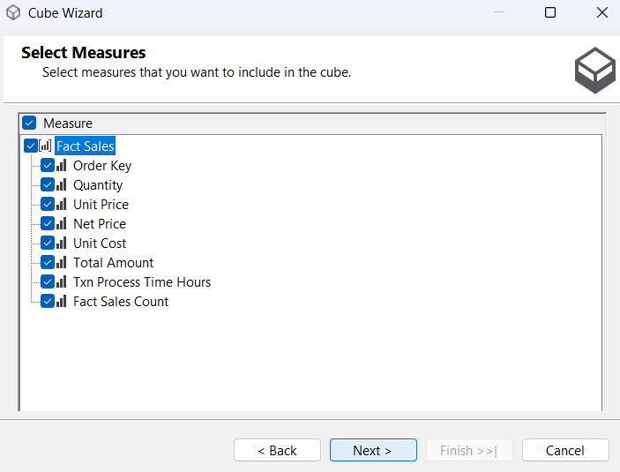

Step 3

Step 4

Step 5

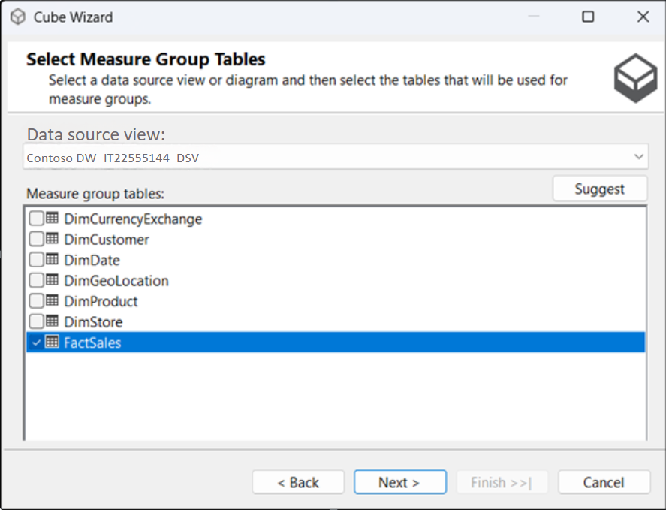

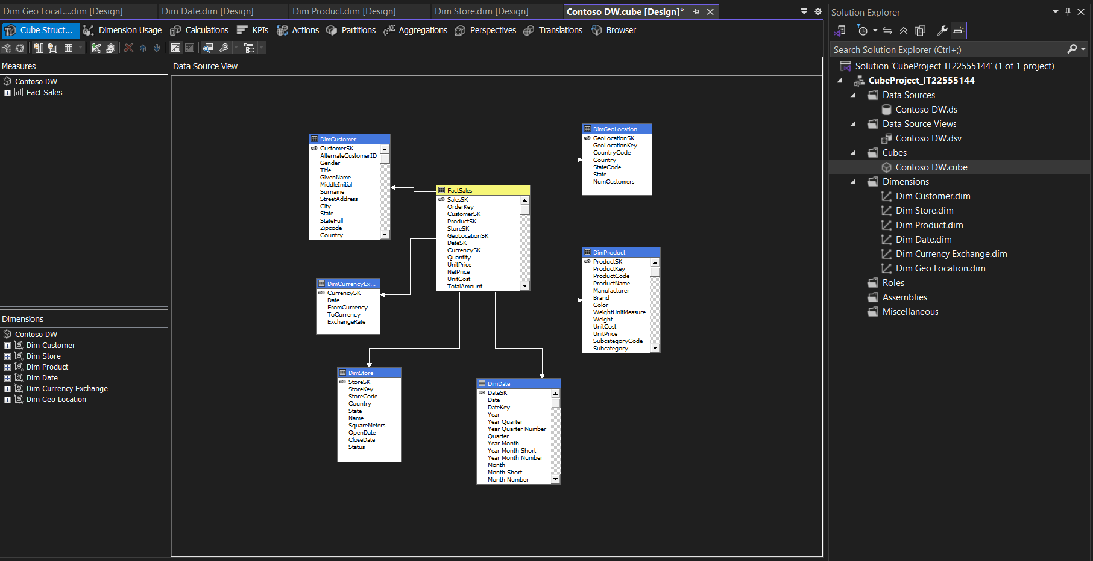

**5. Designing Measures and Dimensions**

* Verified that Measures were correctly created under the Measure Group (FactSales).
* Configured dimension properties:

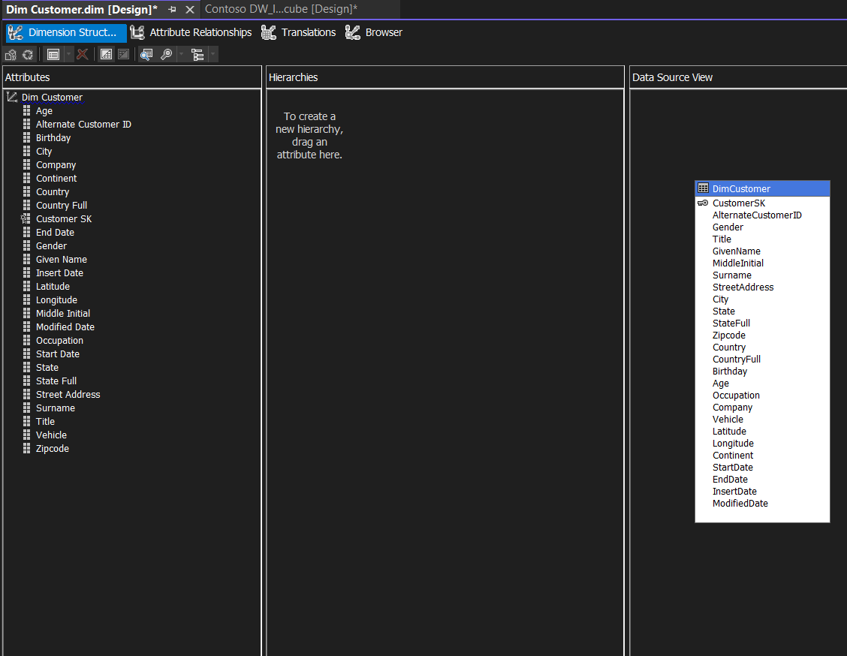**DimCustomer**

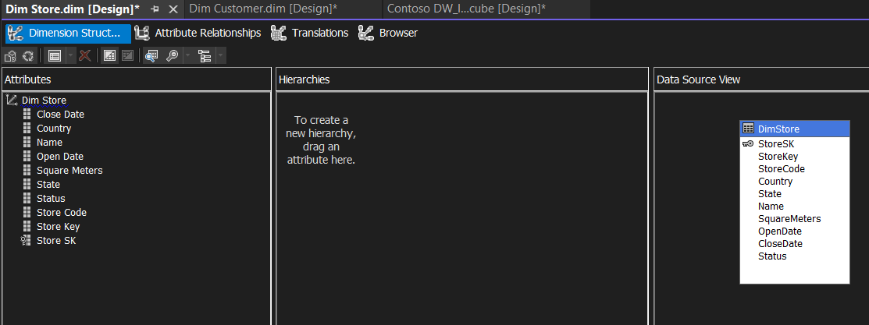**DimStore**

**DimProduct**

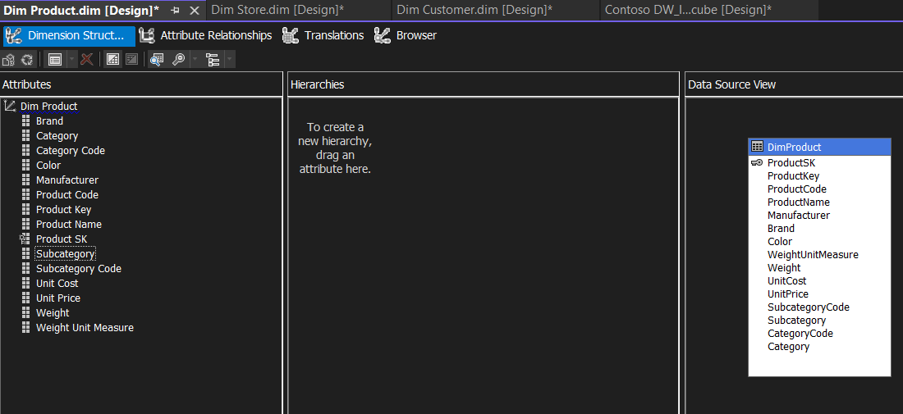

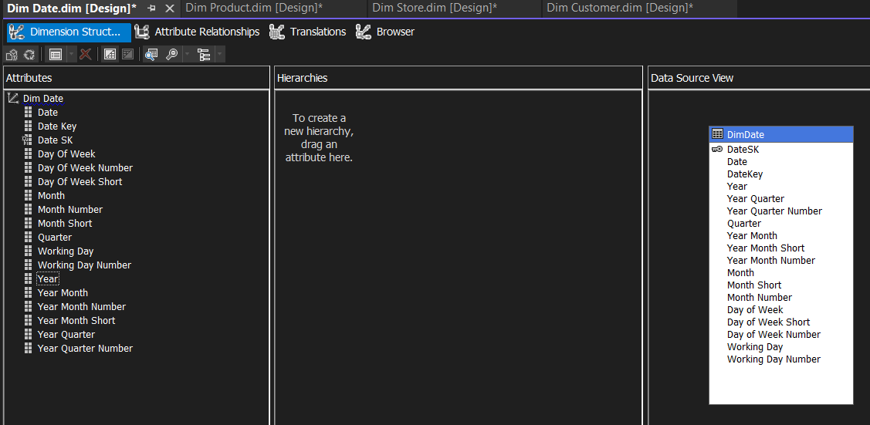**DimDate**

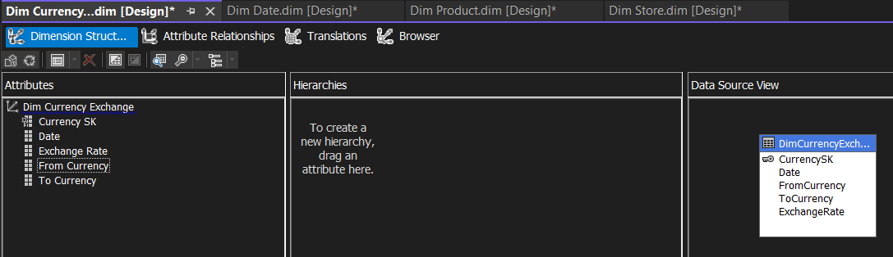**DimCurrencyExchange**

**6. Implementing Hierarchy**

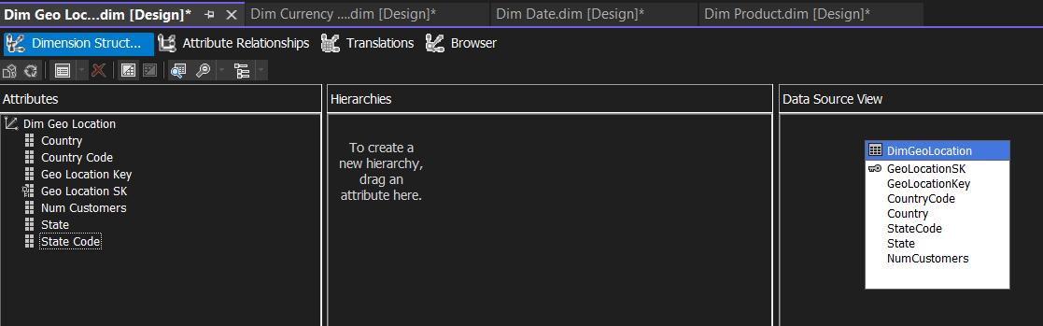**DimGeoLocation**

**6. Implementing Hierarchy**

* Opened Dimension Designer (e.g., **DimDate.dimenstion, DimCustomer.dimension**).
* Created a **Hierarchy**:
  + Dragged attributes like **Year** → **Quarter** → **Month** to form a hierarchy.
  + Dragged attributes, **Country → State → City** to form a hierarchy.
  + Renamed hierarchy as **DateHierarchy**.
* 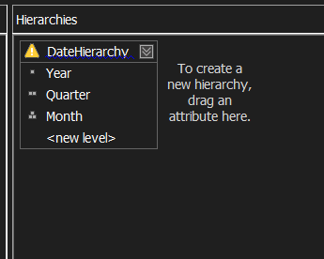Verified Attribute Relationships to optimize query performance.

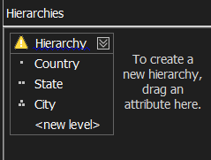

**7. Deploying and Processing the Cube**

* Right-clicked the project → **Properties**.
* Set **Deployment Target Server**.
* Clicked **Deploy** to deploy cube to SSAS server.
* After successful deployment, **processed** the cube:
  + Right-click Cube → **Process** → Start.

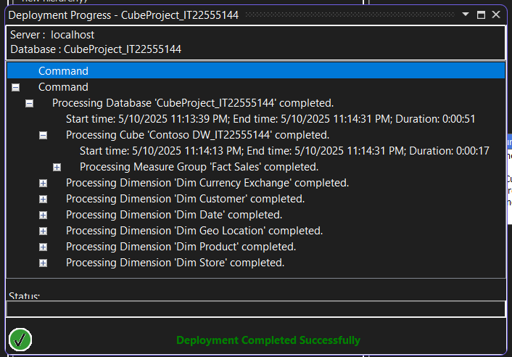Verified cube data loaded successfully.

**8. Testing Cube**

* Opened **Cube Browser** in Visual Studio.
* Dragged measures and dimensions into the browser to test:
  + Confirmed correct aggregation of measures.
  + Tested drill-down through the hierarchy (Year → Quarter → Month).

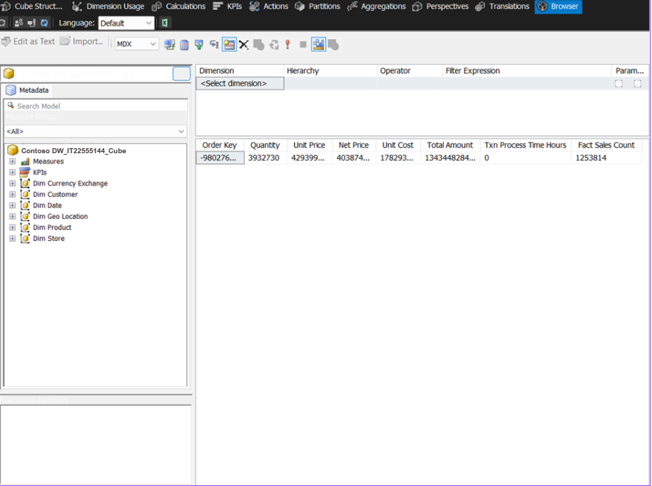

**Step 3: Demonstration of OLAP operations**

**1. Connection to SSAS Cube**

* Opened Microsoft Excel.
* Navigated to **Data → Get Data → From Database → From Analysis Services**.
* Entered server name
* Selected database Contoso_DW and Cube_IT22555144.
* Created a PivotTable connected to the cube.

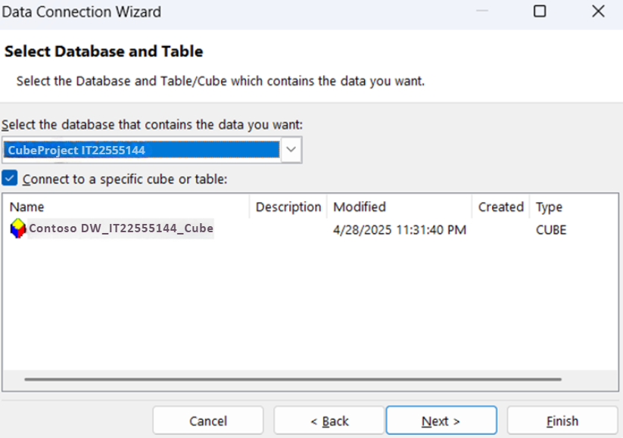

**2. Demonstrate OLAP Operations**

**Roll-up Operation**

In the PivotTable, group data at a higher level. Drag a higher-level attribute (Country) into Rows.

**Steps:**

* In the PivotTable, drag a detailed dimension to Rows (Country under DimCustomer).
* Added a Measure (Total Amount) to Values.
* Next removed Country and replace it with State (a higher-level aggregation).
* This shows a Roll-up: Country → State.

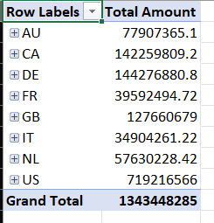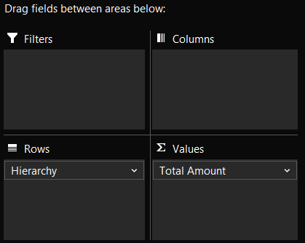

**Drill-down Operation**

Expand a hierarchy to show lower levels (expand Country → State → City). Right-click a Country, and click **Expand**.

**Steps:**

* Started by putting Year on Rows and Total Amount on Values.
* In the PivotTable, double-click on a particular Country.
* Excel will drill down into more detailed data.

**City**

**State**

**Country**

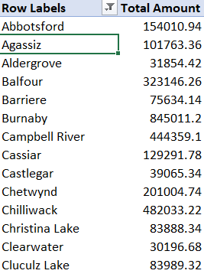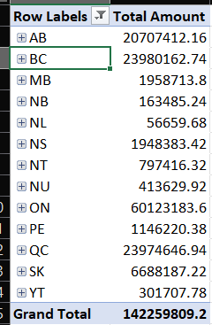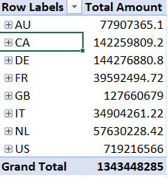

**Slice Operation**

Use a Slicer to filter the data based on dimension (filter sales by Region or Category). Insert → Slicer.

* Insert a **Slicer**: Click the PivotTable → Go to **PivotTable Analyze** → **Insert Slicer**.
* Select **Country** as the Slicer field.
* Now, when click on a country (USA), it filters the whole PivotTable to only show that Country.

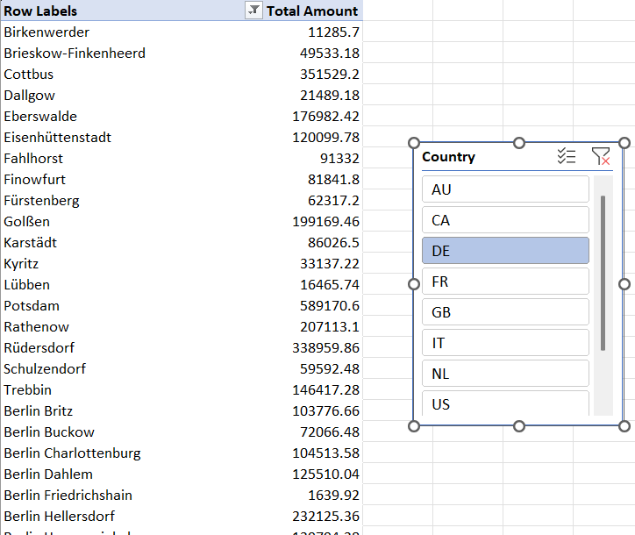

**Dice Operation**

Apply multiple filters to select specific data subsets. Use multiple dimension filters.

**Steps:**

* Insert **two Slicers**:
  + One for **Country**.
  + One for **State**.
* Now apply both:
  + Example: Select **Year = 2025** and **Quarter = Q2**.
* Your PivotTable will now show only data for Q2 of 2025.

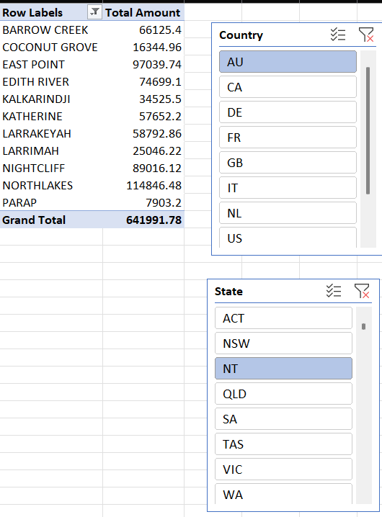

**Pivot Operation**

Rearrange rows/columns in PivotTable. Drag fields between Rows and Columns.

Steps:

* 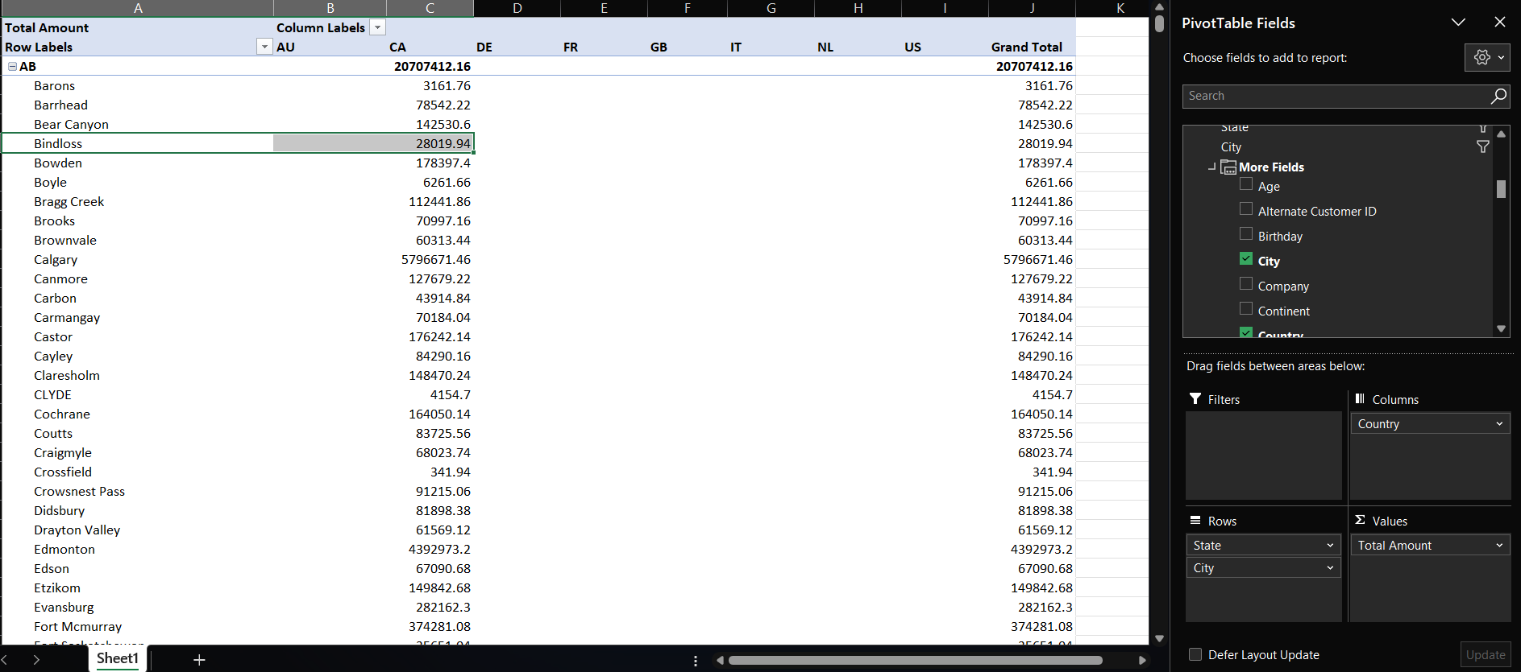In the PivotTable: Drag **Country** to Columns and Drag **State** and **City** into Rows.
* Then swap: Move **State** into Columns and **Country** into Rows.
* 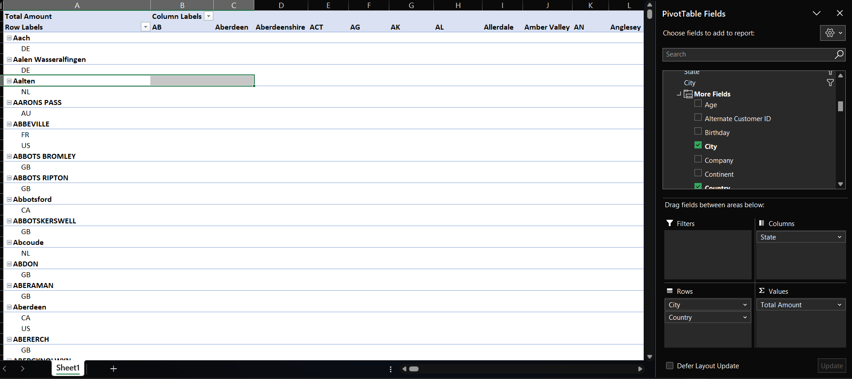This changes the data view (perspective) without changing the data.

**Step 4: PowerBI Reports**

**Steps:**

* Open Power BI Desktop.
* Load the dataset
  + use Home > Get Data, select the source SQL Server (from Contoso_DW).
* Build Relationships between tables (use Model view).
* Save the Power BI file (PowerBIReports_IT22555144).

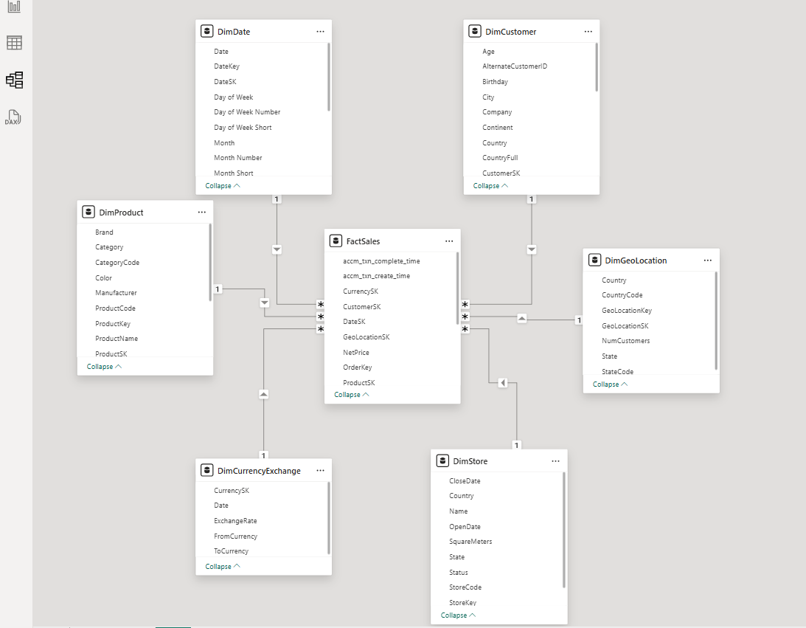Relationships between tables (Model View)

**🔹 Report 1: Matrix Visual (Tabular Data with Row & Column Groupings)**

**Goal**: Create a report showing detailed tabular information grouped into rows and columns.

**Steps**:

1. In Power BI Desktop, go to the Report view.
2. Click Matrix visual from the Visualizations pane.
3. Drag a Category field (Category) into Rows.
4. Drag a Sub-Category field (Manufacturer) into Columns.
5. Drag a Measure (Unit Cost) into Values.
6. Customize formatting (Format pane) – adjust grid lines, style, etc.

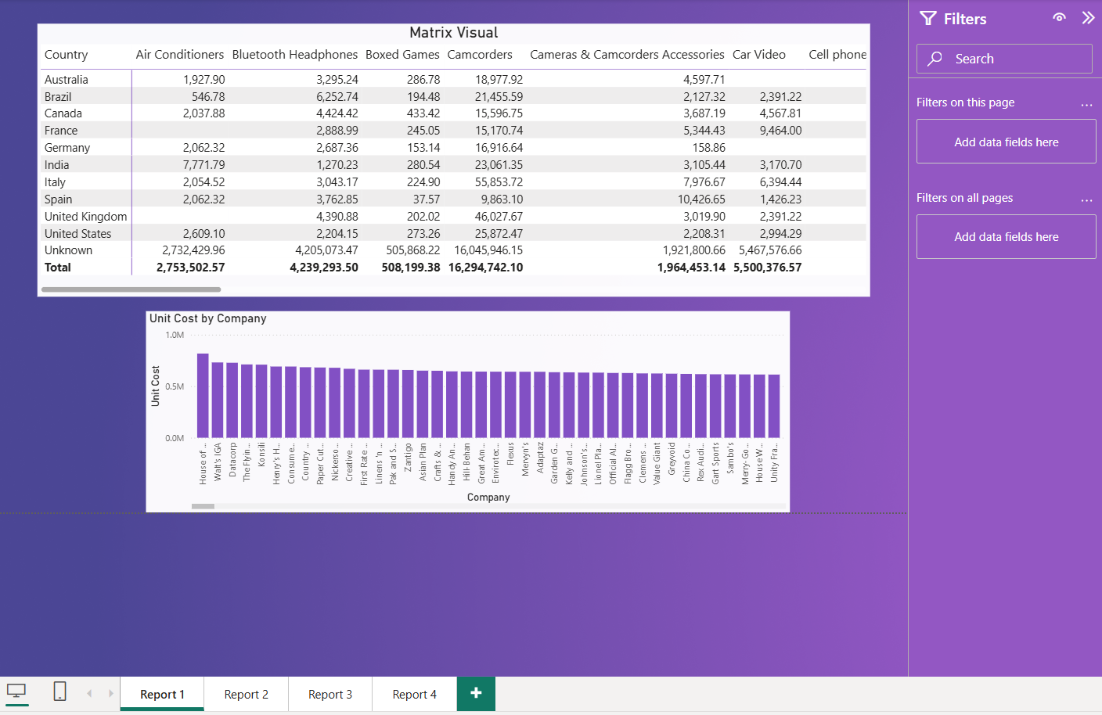

**🔹 Report 2: Slicers (Cascading Filters + Multiple Visuals)**

**Goal**: Use slicers where the second depends on the first (cascade), plus multiple charts.

**Steps**:

1. Insert two Slicer visuals.
2. First Slicer: Add a broader field (Category).
3. Second Slicer: Add a dependent field (SubCategory).
4. Enable cascading:

* Power BI automatically filters if relationships exist correctly.

1. Insert multiple visuals:

* A Bar Chart (UnitCost by Category).
* A Pie Chart (UnitPrice by SubCategory).
* A Line Chart (WeightUnitMeasure by Brand).

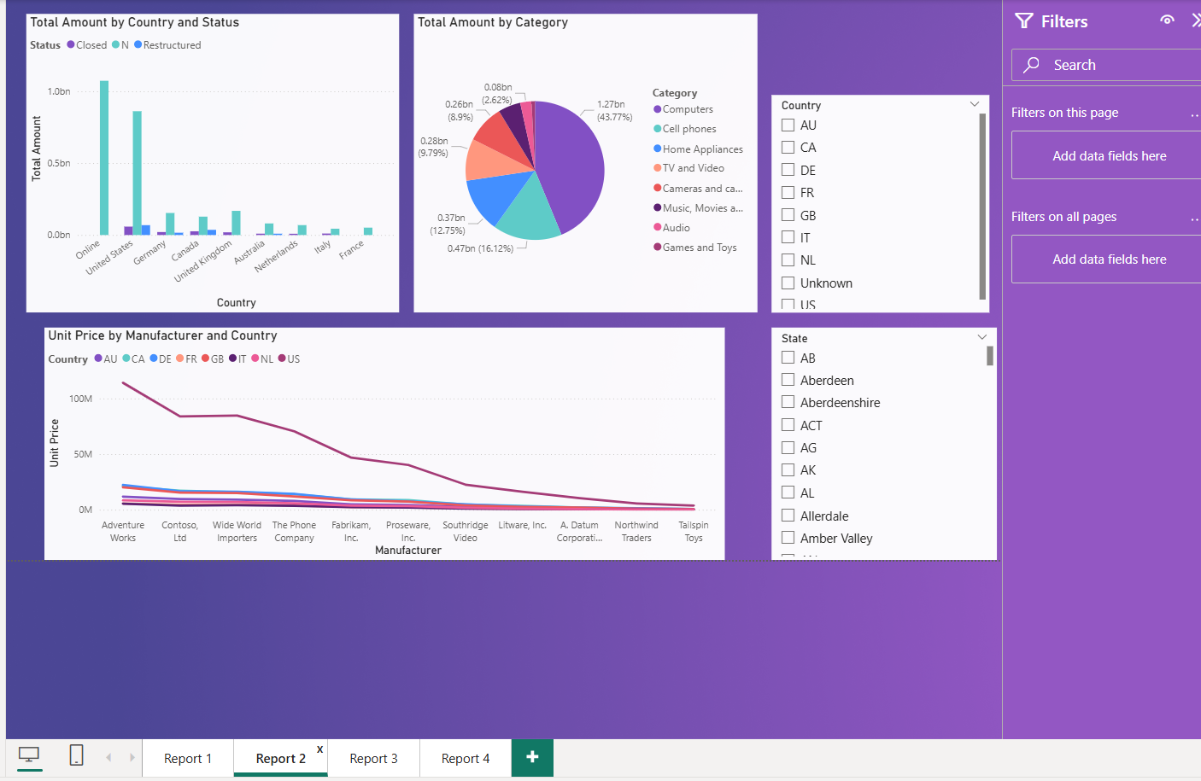

**🔹 Report 3: Drill-Down Report (Hierarchical Data Exploration)**

**Goal**: Allow users to click into details (Country ➔ State ➔ City).

**Steps**:

1. Insert a Column Chart or Line Chart. (Company by Country)
2. Drag multiple fields in the Axis section in hierarchy order.
   * 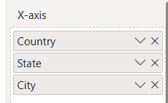Country ➔ State ➔ City
3. Turn on Drill Mode:
   * Select the chart, click the small drill-down arrow (↓) on the top left of the chart.
4. Then, clicking a Country drills into State, clicking a State drills into City.

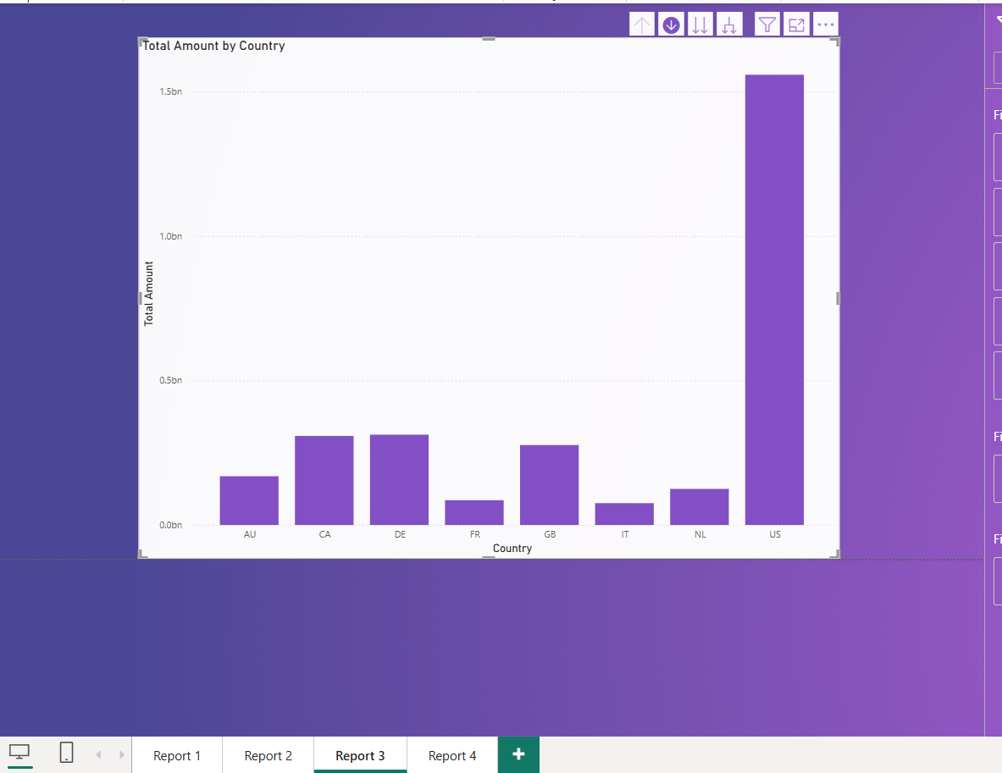

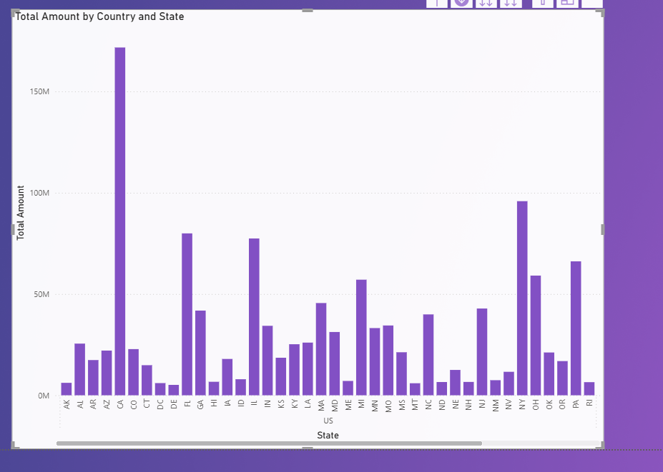

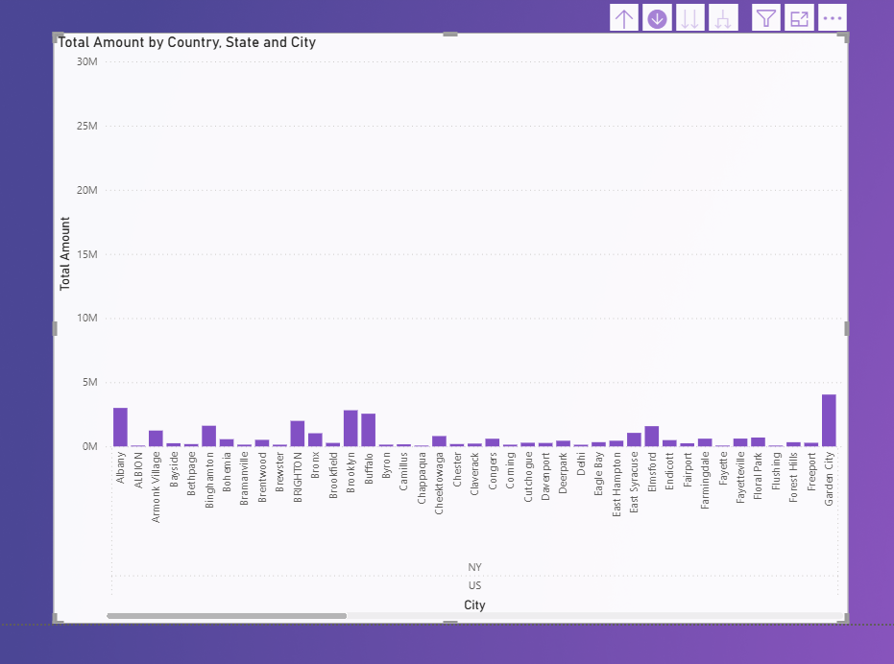

**🔹 Report 4: Drill-Through Report (Right-Click to Detailed Page)**

**Goal**: Create a separate page users can navigate to for more detailed data.

**Steps**:

1. Create a new page. (Report 4)
2. Insert a Drill-through filter:
3. 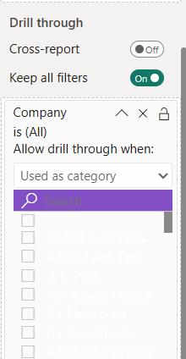Drag a field (Company) into the Drill-through filters well (right side).

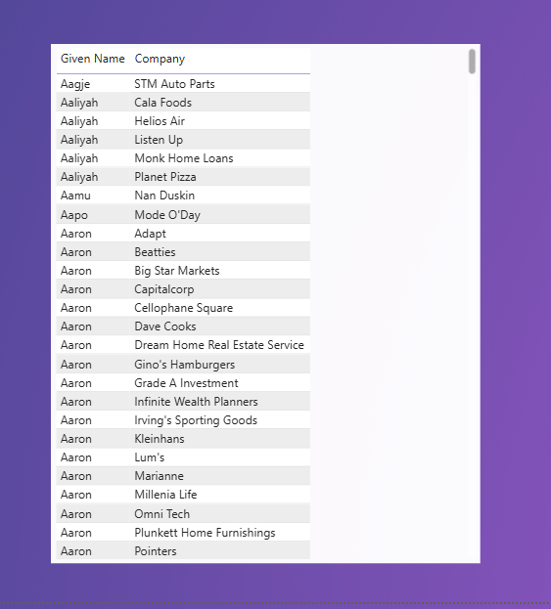

1. Design the drill-through page with detailed visuals (like tables, cards).
2. On the main page:
   * Insert a visual (Bar Chart with Company).
   * Right-click a company ➔ select Drill through ➔ [Your Drill-through Page].

